Problem E
e.c, e.cpp, e.java
e.in, e.out
Background
At this stage, you can imagine the background you want.
Problem
given an initial set of stacks of bricks, your task is to determine the minimum number of moves, to rearrange them so all the stacks are the same height afterwards.
The figure below shows an example of such operation:
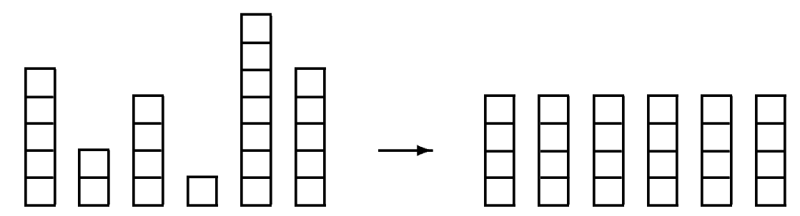
Before after
Input
The input consists of several test-cases. Each one starts with a line containing the number n of stacks.
The next line contains n numbers : the heights hi of the n stacks. You may assume that 1 <= n <= 50 and 1 <= hi <= 100 and the total number of bricks is divisible by n.
The input is terminated by a set starting with n=0, which should not be processed.
Output
For each test case, first print the number of the test-case, as shown in the sample output. Then print the line : « The minimum number of moves is k. », where k is the minimum number of bricks to be moved in order to make the bricks the same height.
Output a blank after each line.
Sample input
6
5 2 4 1 7 5
0

Sample output
Set #1:
The minimum number of moves is 5.

